Todd Goldfinger

Damian Yerrick

Implementation of JPEG-like Compression
10/24/02
Mathematics of Image Processing

Introduction

1) Signal compression

The basic algorithm for lossy signal compression is as follows:

1. Put the signal X through a reversible transformation, generally a linear map, to get Xhat. For good compression, this transformation should concentrate most of the image's energy in relatively few coefficients.
2. Quantize Xhat into Xhatq. This can be as simple as scalar quantization, where you divide the transform coefficients elementwise by a matrix of values and round to the nearest integer.
3. Code the quantized Xhat using a reversible entropy coder such as RLE + Huffman (used in JPEG) or LZSS + Huffman (used in PKZIP).

To decompress the image, apply the inverses:

3^-1. Decode the bitstream using the inverse of the entropy coder, producing Xhatq.
2^-1. Rescale Xhatq into Xhat'. Note that you can't undo the rounding.
1^-1. Use the inverse of the original transformation to reconstruct X'.

2) DCT image coding

Image coding based on the discrete cosine transform subdivides the image into equally sized tiles, usually 8x8 pixels each. It then applies an orthogonal transform

3) The DCT

The discrete cosine transform is an orthonormal transform used to transform a short section of a signal into a domain where the energy is more tightly packed, and more elements come close to zero. Refer to section 4.5, definition 4.2 of Dr. Broughton's notes for the definition of the discrete cosine transform.

The DCT is implemented with a matrix, the DCT matrix, with N rows and N columns for an N-point DCT. The rows of the DCT matrix are composed of scaled samples of a cosine function with 0, 1/2, 1, 3/2, 2, up to (N - 1)/2.
The most common size of DCT in use in image compression is the 8-point DCT:
_ _
| 0.3536 0.3536 0.3536 0.3536 0.3536 0.3536 0.3536 0.3536 |
| 0.4904 0.4157 0.2778 0.0975 -0.0975 -0.2778 -0.4157 -0.4904 |
| 0.4619 0.1913 -0.1913 -0.4619 -0.4619 -0.1913 0.1913 0.4619 |
C8 = | 0.4157 -0.0975 -0.4904 -0.2778 0.2778 0.4904 0.0975 -0.4157 |
| 0.3536 -0.3536 -0.3536 0.3536 0.3536 -0.3536 -0.3536 0.3536 |
| 0.2778 -0.4904 0.0975 0.4157 -0.4157 -0.0975 0.4904 -0.2778 |
| 0.1913 -0.4619 0.4619 -0.1913 -0.1913 0.4619 -0.4619 0.1913 |
|_0.0975 -0.2778 0.4157 -0.4904 0.4904 -0.4157 0.2778 -0.0975_|

Thus, the one-dimensional DCT can be performed on a column-vector:

Vhat = C8 * V

or on a row-vector:

Rhat = R * C8'

where * denotes matrix multiplication and ' denotes matrix transposition.

Because the DCT is orthonormal, its multiplicative inverse is its transpose:

C8 * C8' = I

Thus, multiplying a vector by the DCT's transpose undoes the DCT:

V = C8' * Vhat
R = Rhat * C8

Note that when taking, say, 8-sample chunks of a signal on which to perform the DCT, the signal must be padded to a multiple of 8 samples in length. There are three ways to do this. First of all, the compressor could set all the extra samples to a constant value. Second, to create a smaller discontinuity, it could use the last defined sample as the constant value, rather than zero. But the best results are obtained by "reflecting" the edge samples into the spaces; this creates some pseudo-periodicity that improves how the DCT sees the block.
4) Extension to two dimensions

The definition of the DCT can be extended to two dimensions by treating the rows of a matrix as row vectors and then treating the columns of the matrix as column vectors.

Mhat = C8' * Mhat * C8
M = C8 * Mhat * C8'

This is called a "separable" transform because it is performed separately along the axes.

5) Scalar quantization

After a well-designed transform, many coefficients of the transformed image will have become close to zero. A coder will then "quantize" the coefficients, that is, round them to the nearest integer. Once the transform concentrates in a few coefficients, rounding off the coefficients won't produce much distortion. In addition, the eye is somewhat less sensitive to high frequencies than to low frequencies, and it's possible to achieve more compression by attenuating the higher frequencies.

6) Measuring entropy

Coding performance is often stated in terms of a measure called "entropy".

1. Make a histogram of all quantized values. Each distinct quantized value should get its own bin. This will give you a vector 'n'.
2. Divide 'n' by the sum of all elements in 'n'. This gives a vector 'percentn', the probability that a word will fall into each bin.
3. Remove the zero elements, which represent quantized values that are never used, from 'percentn'.
4. The definition of entropy, from Shannon's information theory, states that if p is the probability that any word will fall into a given bin, then the optimal encoding for that word has -log2(p) bits, where log2 is the logarithm to base 2.
5. Now find the weighted average number of bits that a word will take. This equals the dot product of percentn and -log2(percentn)

The entropy represents the ideal case of any coder. In practice, the use of, say, a huffman coder would have slightly less efficient compression (bpp).
7) Strengths and weaknesses of implementation

This implementation uses a simple and relatively quick algorithm. However, it does not run very quickly since the code is in matlab. There is a parameter to control the quality. Note that the image gray scale values must be scaled between 0 and 1 for the quality parameter to work correctly. Quality should be set between 1 and 255 where 255 is the best quality. One problem is images are required to be gray scale.

8) Suggestions for further work

Sort the coefficients by increasing spatial frequency. This will achieve progressive transmission by sending a low-resolution image and then gradually refining it. It may even be able to improve compression by making use of this distribution of the coefficients. That is, the coefficients may be easier to compress if they are ordered.

Investigate transforms other than DCT, such as WHT or wavelets, that may be faster to compute on hardware less powerful than a PC.

Investigate vector quantization of coefficients, which is said to produce less noise than scalar quantization.

Investigate compression of color images.

9) Conclusions

By looking at the images and entropy-distortion graph, it is clear that we have obtained decent compression. We have suggested a few improvements. Also, after two percent the distortion seems to increase rather quickly with decreasing entropy. So, generally it is not worth trying to lower the quality considerably to decrease entropy. And this may not be necessary since at the highest quality setting, the bit rate is already 5 fold better than the uncompressed bit rate.

9) Credits

Program design by Damian Yerrick.
Matlab code by Todd Goldfinger and S. Allen Broughton.
Report by Damian Yerrick.
Report edited and formatted by Todd Goldfinger.
Appendix

The following is a plot of entropy vs distortion for a gray scale version of the clown image using a quality of 255. Note that some rows and columns were left off to demonstrate that the image does not require rows and columns to be multiples of eight. As expected, when the entropy becomes small, the distortion becomes large. For one bit per pixel, the entropy is at about 2 percent. This is probably slightly worse image quality than acceptable. To verify a point on this graph, compress the clown image with winzip 8.0 at full quality. You will see that the compression is approximately (15000bytes*8bits/byte)/(64000pixels)=1.9 bpp. This is about .3 bpp larger than the value of the first point on the entropy-distortion graph.

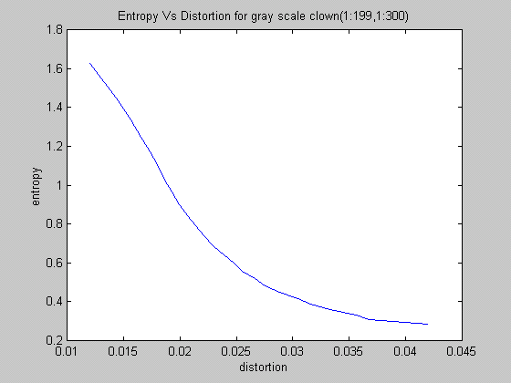
The following demonstrate what the images look like at various qualities (20, 80, and 255). Notice that at a quality of 80, the image looks decent. Again, these images drop the last row and last 20 columns of the grayscale clown image.

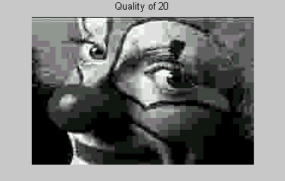
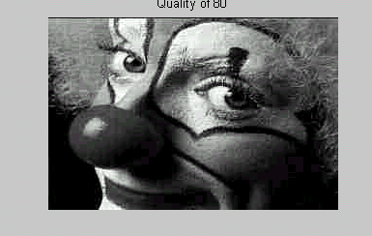
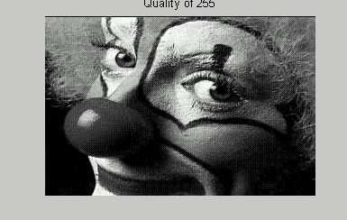

Code

function Y=encode(X,quality)
% Modified by Todd Goldfinger (originally blkdct2)
%
% compute the 2D dct of mxn sub-blocks of X
% m must divide the # of rows of X
% n must divide the # of columns of X
% for small blocks the dct2 is computed faster by matrix multiplication
% that by using the dct2 command
%
% quantizes image as it does the dct
qnt=1/quality*[16 11 10 16 24 40 51 61; 12 12 14 19 26 58 60 55; 14 13 16 24 40 57 69 56; 14 17 22 29 51 87 80 62; 18 22 37 56 68 109 103 77; 24 35 55 64 81 104 113 92; 49 64 78 87 103 121 120 101; 72 92 95 98 112 100 103 99];
m=8;n=8;
[r,s] = size(X);
Y = zeros(r,s);
C1 = dct(eye(m));
C2 = dct(eye(n))';
for i=1:(r/m)
for j=1:(s/n)
e = (i-1)*m+1;
f = (j-1)*n+1;
Z = X(e:(e+m-1),(f:f+n-1));
Y(e:(e+m-1),(f:f+n-1)) = round((C1*Z*C2)./qnt);
end;
end;

%at this point you can compress the file
function [transformedImg,bytes]=writeTransformedImage(img,file,quality)
%pads img using reflection so that rows and columns are a multiple of 8
%then the image is transformed and written to file
%quality needs to be between 1 and 255
%file is the directory and name of the file to be written
%returns the transformed image and the number of bytes in the file written

s=size(img);
h=s(1);w=s(2);
padr=8-mod(h,8);
padc=8-mod(w,8);
tmp=img;

%add extra rows and colmuns if necessary
if(padr~=8)
tmp=[tmp; zeros(padr,w)];
end
if(padc~=8)
%use mod here in case the rows are actually a multiple of 8
tmp=[tmp zeros(h+mod(padr,8),padc)];
end

%fill rows with the image reflected about the last row
if(padr~=8)
tmp([h+1:h+padr],:)=tmp([h-1:-1:h-padr],:);
end
%fill columns with the colmun reflected about the last column
if(padc~=8)
tmp(:,[w+1:w+padc])=tmp(:,[w-1:-1:w-padc]);
end

%should be the number of bytes written to file
bytes=6+length(tmp(:));
transformedImg=encode(tmp,quality);
fid = fopen(file,'wb');
%write out the height and width of the original image as well as the quality
%(note that an extra byte is used for quality - this can be shaved off)
fwrite(fid,[h w quality],'integer*2');
fwrite(fid,transformedImg,'integer*1');
fclose(fid);
function [img,quality,bytes]=readTransformedImage(file)
%Read in an image and transform it back to the spatial domain
%file is the directory and name of the file to read
%returns:
%img is the spatial domain image
%quality is the quality of that image
%bytes is the number of bytes read from the file

fid = fopen(file,'r');
s=fread(fid,3,'integer*2');
%these are the height and width of the original image
h=s(1);
w=s(2);
quality=s(3);
%these are corrections that tell us how much was actually
% written to file
offt=8-mod(h,8);
offw=8-mod(w,8);
if(offt==8) offt = 0; end
if(offw==8) offw = 0; end
[transformedImg bytes]=fread(fid,[h+offt w+offw],'integer*1');
bytes=h*w+6;
fclose(fid);

%decode the image and remove the reflected parts
img=decode(transformedImg,quality);
img=img(1:h,1:w);
function Y=decode(X,quality)
% Modified by Todd Goldfinger (originally blkidct2)
%
% compute the inverse 2D dct of mxn sub-blocks of X
% m must divide the # of rows of X
% n must divide the # of columns of X
% for small blocks the idct2 is computed faster by matrix multiplication
% that by using the idct2 command
%
% dequantizes image as the dct is done
qnt=1/quality*[16 11 10 16 24 40 51 61; 12 12 14 19 26 58 60 55; 14 13 16 24 40 57 69 56; 14 17 22 29 51 87 80 62; 18 22 37 56 68 109 103 77; 24 35 55 64 81 104 113 92; 49 64 78 87 103 121 120 101; 72 92 95 98 112 100 103 99];
m=8;n=8;
[r,s] = size(X);
Y = zeros(r,s);
C1 = idct(eye(m));
C2 = idct(eye(n))';
for i=1:(r/m)
for j=1:(s/n)
e = (i-1)*m+1;
f = (j-1)*n+1;
Z = X(e:(e+m-1),(f:f+n-1));
Y(e:(e+m-1),(f:f+n-1)) = (C1*(Z.*qnt)*C2);
end;
end;
%This script creates a plot of entropy vs distortion
%It is assumed that the variable clown holds a gray scale
% image of matlab's clown image

entropy=[];
distortion=[];
quality=[];

%create a graph with 26 points
%the quality deteriorates exponentially so we can get a good curve for
% entropy vs distortion
for i=0:25
%remove some rows and columns to demonstrate padding
c=clown(1:199,1:300);
[transformedImg,b]=writeTransformedImage(c,'c:\windows\desktop\clown.bin',255*exp(-i/10));
%create a histogram of bytes from the transformed image
n=hist(transformedImg(:),256);
%find the percent of bytes in each bin
percentn=n/sum(n);
%remove the zeros
percentn=percentn(find(percentn~=0));
%find the entropy - this estimates what compression would
% be if we used, say, winzip
e=dot(percentn,-log2(percentn));
entropy=[entropy e];
[img,q,b]=readTransformedImage('c:\windows\desktop\clown.bin');
%calculate distortion using the standard defn. (in decimal not percent)
d=c-img;
d=dot(d(:),d(:))/dot(c(:),c(:));
distortion=[distortion d];
quality=[quality q];
end

plot(distortion,entropy);

