MiniMips Documentation

Group M
Tim Spatzek
Todd Goldfinger
Tom Schneider

J.P. Mellor
February 13, 2001

Table of Contents

1 Executive Summery 1
2 Instruction Set Architecture 2
2.1 The Instructions 2
2.2 The Bit Fields 3
2.3 MiniMips Compiler Program 4
2.4 The RTL 5
3 Data path 6
3.1 Add Two 7
3.2 Data Path 8
3.3 ALU 11
4 Control 12
5 Testing 13
5.1 Testing Methodology 13
5.2 Test Programs 14
6 Looking Back 16

Executive Summery

In designing our data path we chose to use simplicity and expandability as our key design feature. When we started we used the same basic interface as the multi-cycle datapath in our CS232 book. One key design feature we used was the splitting the immediate field in some instructions. This did not effect our instruction set and allowed us to simplify our datapath greatly. Another major decision we added was the “jal” and “jr” instructions. We realized we needed these instructions to have functions. Another design decision was since we were not using bye addressing we shifted the “lw” instruction to get double immediate range.

We would have liked to have a cleaner version before implementing in Xilinx. Most all of our time was spent working in Xilinx. If we worked all the bugs out of or datapath before inputting it into Xilinx we would have had less trouble and time spend debugging in software. Of course if we had more time, effort, and not so many problems we could have improved our data path and added more complex and interesting instructions.

Instruction Set Architecture

The Instructions

The MiniMips instruction set is a distilled version of the Mips instruction set, following most of the same conventions. Overall, MiniMips has 9 registers: $1-$7, and $ra. It also has 256 bytes of memory addressed with 2 byte words. With only 12 instructions MiniMips can implement a surprising variety of functions. All arithmetic operations, memory accesses and stores are supported. “bne” and “beq” allow all possible comparison branching and “j”, “jr” and “jal” allow for jumping and procedure calls. Basic shifting can be accomplished by using “add”s, more complex shifting would require implementing a barrel shifter. The “and” and “or” instruction can be added later. By combining an “addi” with a “lui”, a full 16-bit immediate can be loaded. However, “lui” can only load numbers into the upper 10 bits of $0-$3.

Table 1: The Instruction Set
Category | Instruction | Example |  |  |  | Meaning
Arithmetic | add | addi | $0, | $1, | $2 | $0 = $1 + $2
Arithmetic | subtract | sub | $0, | $1, | $2 | $0 = $1 - $2
Arithmetic | add immediate | addi | $0, | $1, | 4 | $0 = $1 + 4
Data transfer | load word | lw | $0, | $1, | 2 | $0 = Memory[$1 + 4]
Data transfer | store word | sw | $0, | $1, | 2 | Memory[$1 + 4] = $0
Data transfer | load upper immediate | lui | $0, | 12 |  | $0 = 12 * 2^6
Conditional branch | branch on equal | beq | $0, | $1, | 8 | if ($0 == $1), jump to 8
Conditional branch | branch on not equal | bne | $0, | $1, | 8 | if ($0 != $1), jump to 8
Conditional branch | set on less than | slt | $0, | $1, | $2 | if ($1 < $2) then $0 = 1, else $0 = 0
Unconditional jump | jump | j | 8 |  |  | go to 8
Unconditional jump | jump register | jr | $ra |  |  | go to $ra
Unconditional jump | jump and link | jal | 8 |  |  | $ra = PC + 2; go to 8

The Bit Fields

Bits [15-12] always hold the Op Code and bits [11-0] can all hold an immediate value depending on the instruction. To simplify the data path design, registers can only be read by using bits [11-9], registers can be read and written to using bits [8-6], and registers can only written to using bits [5-3]. To further simplify the hardware design, immediate instructions break their immediate bit field into two parts. Several instructions don’t use the entire 16-bits, as denote in the following table. On a side note, “jr” sets last bit to 1 if using $0-$7 or sets the last bit to 0 if using $ra.

Table 2: The Bit fields
Type | Example |  |  |  | 15 | 14 | 13 | 12 | 11 | 10 | 9 | 8 | 7 | 6 | 5 | 4 | 3 | 2 | 1 | 0
R | addi | $0, | $1, | $2 | 0 | 0 | 0 | 0 | 0 | 0 | 0 | 0 | 0 | 1 | 0 | 1 | 0 | X | X | X
R | sub | $0, | $1, | $2 | 0 | 0 | 0 | 1 | 0 | 0 | 0 | 0 | 0 | 1 | 0 | 1 | 0 | X | X | X
I | addi | $0, | $1, | 4 | 0 | 0 | 1 | 0 | 0 | 0 | 0 | 0 | 0 | 0 | 0 | 0 | 1 | 1 | 0 | 0
I | lw | $0, | $1 | 2 | 0 | 1 | 0 | 0 | 0 | 0 | 0 | 0 | 0 | 0 | 0 | 0 | 1 | 0 | 1 | 0
I | sw | $0, | $1 | 2 | 0 | 1 | 0 | 1 | 0 | 0 | 0 | 0 | 0 | 0 | 0 | 0 | 1 | 0 | 1 | 0
L | lui | $0, | 12 |  | 1 | 0 | 1 | 1 | 0 | 0 | 0 | 0 | 0 | 0 | 1 | 0 | 0 | 1 | 0 | 0
I | beq | $0, | $1, | 8 | 0 | 1 | 1 | 0 | 0 | 0 | 1 | 0 | 0 | 0 | 0 | 0 | 1 | 0 | 0 | 0
I | bne | $0, | $1, | 8 | 0 | 1 | 1 | 1 | 0 | 0 | 1 | 0 | 0 | 0 | 0 | 0 | 1 | 0 | 0 | 0
R | slt | $0, | $1, | $2 | 0 | 0 | 1 | 1 | 0 | 0 | 0 | 0 | 0 | 1 | 0 | 1 | 0 | X | X | X
J | j | 8 |  |  | 1 | 0 | 0 | 0 | 0 | 0 | 0 | 0 | 0 | 0 | 0 | 0 | 1 | 0 | 0 | 0
J | jr | $ra |  |  | 1 | 0 | 0 | 1 | X | X | X | X | X | X | X | X | X | X | X | 0
J | jr | $1 |  |  | 1 | 0 | 0 | 1 | X | X | X | X | X | X | 0 | 0 | 1 | X | X | 1
J | jal | 8 |  |  | 1 | 0 | 1 | 0 | 0 | 0 | 0 | 0 | 0 | 0 | 0 | 0 | 1 | 0 | 0 | 0

Legend
value
immediate
read
write

MiniMips Compiler Program

The compiler works very much like any MIPS compiler. There are a few differences, however. For a “lw”/”sw”, there are three fields instead of two. The last field is the address offset amount. Also, unlike MIPS, memory accesses shift the offset by two because the smallest amount of accessible data is two bytes. The “lui” can only access registers 0 to 3. It takes a ten bit immediate value. L and R type instructions take six bit immediate values. J types take a twelve-bit value, except for “jr”. “Jr” takes a register 0 to 8, where 8 is the register that “jal” writes to. Only “jr” can access register 8. Because there is no data or code section and code starts at address zero, there is a special pseudoinstruction, “byte”, that lets you insert any number that you want at the current address. Also, there are no labels; you have to put numbers in for branches and jumps. And branches do NOT add two to the program counter. Finally, a comment is a semicolon. There can be no blank lines in the code. There must be spaces after commas.

Table 3: Sample code comparisons
MIPS Code (16 bit) | MiniMips Code (16 bit)
add $1, $2, $3 | add $1, $2, $3
sw $4, 8($2) | sw $4, $2, 4
lui $0, 100 | lui $0, 100 ($0-$3 only)
jr $ra | jr $8
j end | j 52
bne $2, $1, loop | bne $2, $1, 20
addi $1, $2, 20 | addi $1, $2, 20
NA | byte 2222

The Register Transfer Language

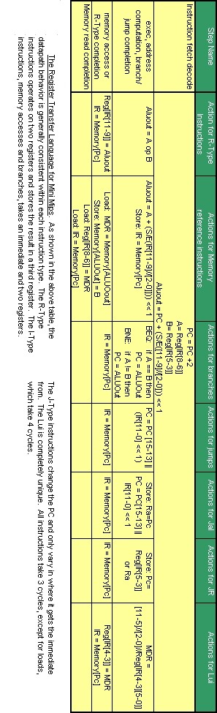

Data path
Descriptions of major and special components are listed below.

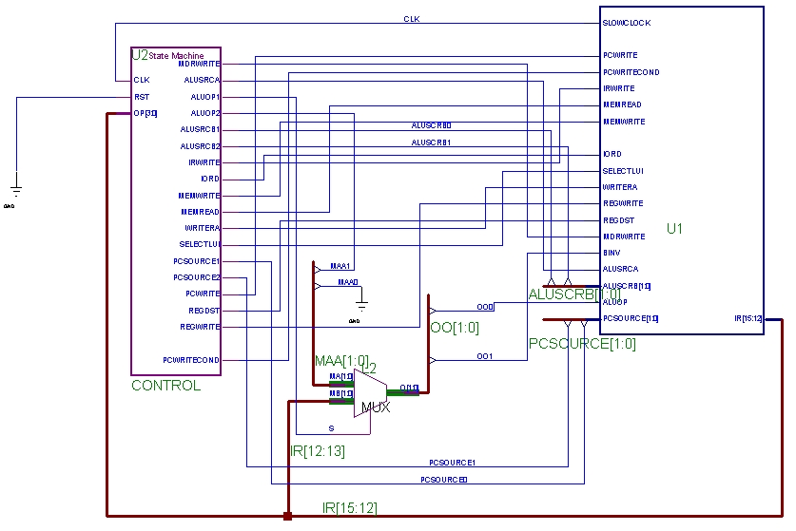

Add Two

The Instruction Fetch stage was merged with the Instruction Decode stage. This was done by adding a special piece of hardware to add two to even numbers and moving the decode (IRWrite) to later stages, depending upon the instruction. The add-two hardware uses some combinatorial logic to implement the following strategy. You can add two to a binary number by isolating the first bit after the string of ones which follows bit 1. Now take the number (the PC) and zero out the string of ones just mentioned. OR this value with the singled out bit. Congratulations! You have now added two. You can see this in the ADD2 hardware. The 15 nands set all bits before the string of ones to one and all bits after to zero. This value (A) is NOTed and shifted left one and ANDed (B). A and B are ANDed; this singles out the important bit. A is ANDed with the PC (C) to remove the string of ones. A and C are ORed to yield the final result. Using this hardware, we can increment the PC without the use of the ALU. This allows considerable freedom. Unfortunately we don't know how to compare the speed of this solution to the old one. 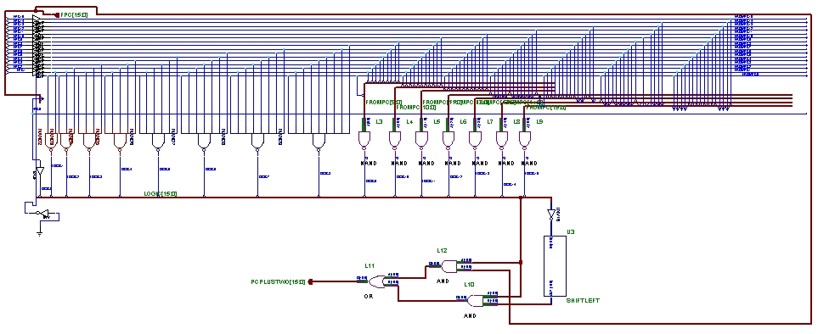

Data Path
The data path is similar to MIPS. I will only mention the changes. The muxes (such as the ones that lead to the PC) have been reordered, but it is easy enough to see which signals go where. The MDR has become a bit of a misnomer because it no longer only writes a register from memory. It is now register write completion. It writes to register from lui, lw, add, sub, slt, and immediates. The only reason control doesn't complete non-immediate register writes is because it writes from a different register field and this requires different signals. The data path also has a 4-AND right in the middle of the diagram. This is just control for lui; of course, this could have been done in control, but this would have taken a lot of agonizing time to do in xilinx. The data path also has a special purpose RA register that can only be written to by jal. It can only be read by jr (if the last bit is an instruction is a zero). There is a an xor at the top that decides between bne and beq. One input is from the zero bit (this is zero if all bits are zero); the other bit is instruction bit twelve. Near the bottom of the data path, you can see the six immediate values being "glued" back together, sign extended, and shifted (for lw/sw/branches).

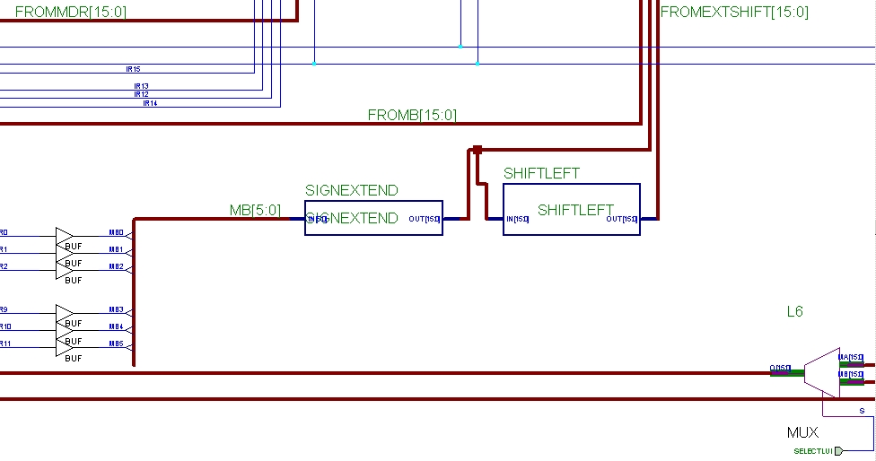

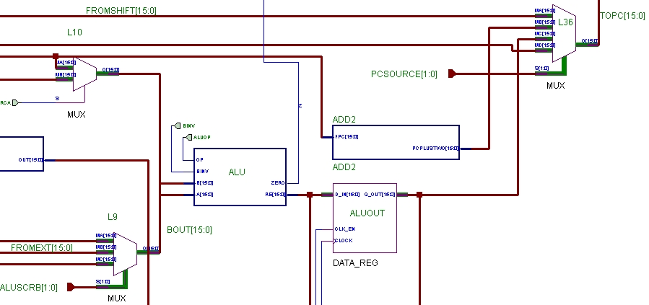

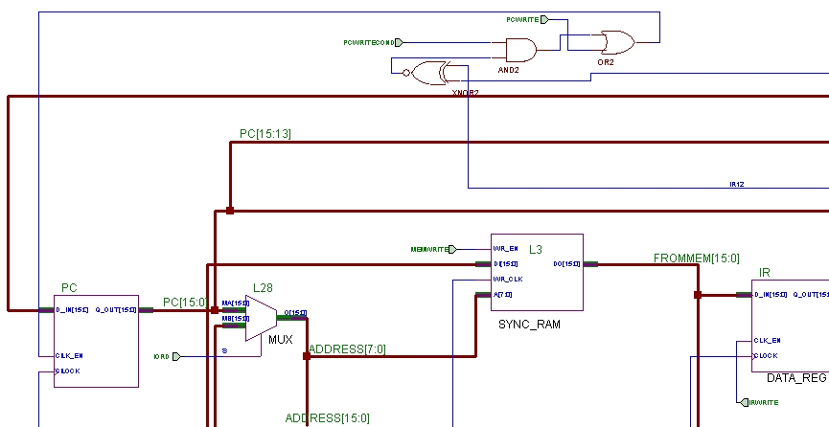

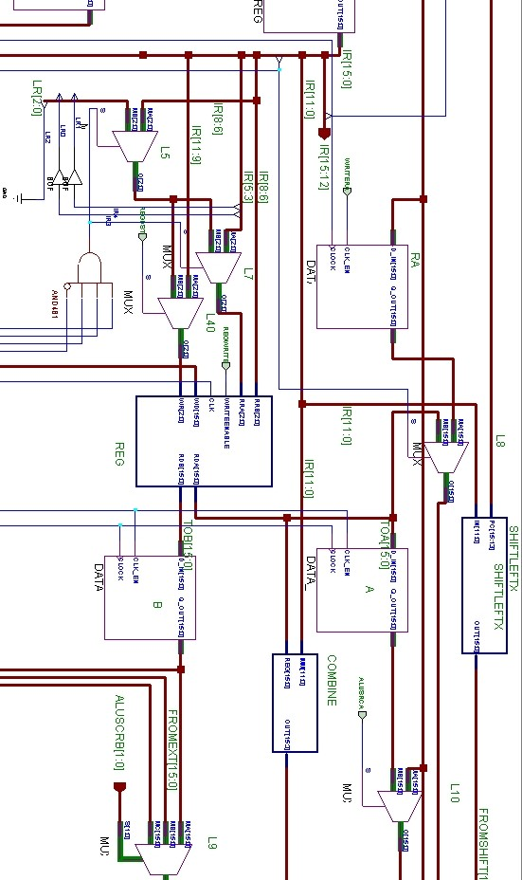

ALU

For the ALU we chose to design something simple and easy. We geared our design for simplicity and expandability. Our ALU consists of the following operations: add, subtract, and a set less than. We designed the ALU similar to one in our cs232 book. We did not incorporate carry-look ahead, so the carry rippled through. 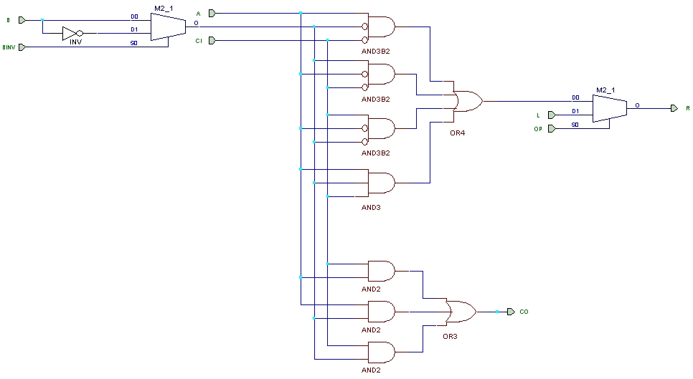

Control
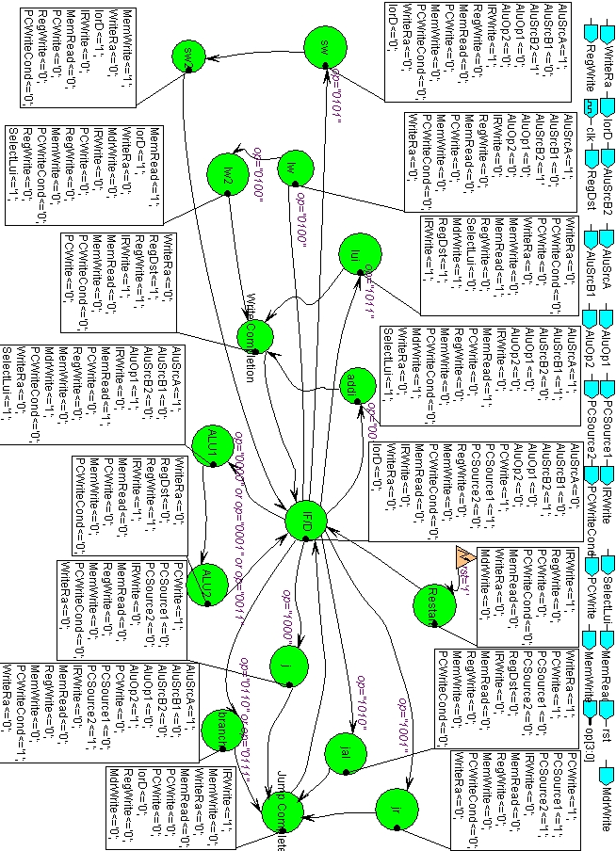

Testing

Testing Methodology

Going into the project we had no testing strategy. As a result, a lot of bugs would go unnoticed. The reason this happened was because often, while testing instructions, all the fields would be set to similar values. So, even though the tests would pass, the wrong bits were being passed along. They just happened to have the correct values on them. Ultimately, testing was a long and laborious process where we would check the test program, fix bugs, test, fix, etc. In the future I would set up a strategy where you test two to three instructions at a time to start with. Each instruction should have very "colorful" fields (as opposed to all zeros) so bugs don't get overlooked.

Test Programs
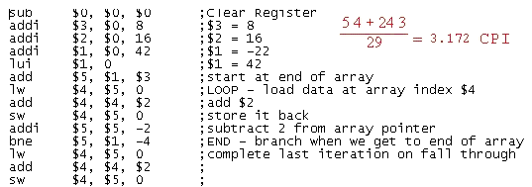
This required test program when translated by the compiler produces this .mem file.

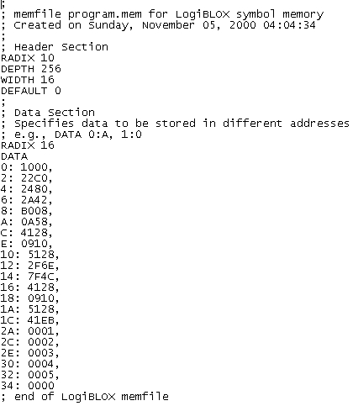
The next program tests the remaining instructions.

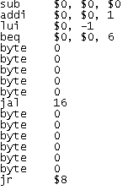

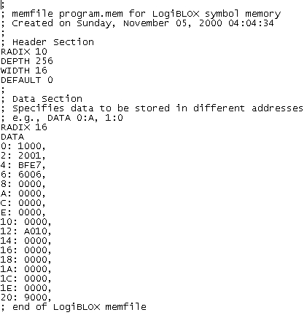

Looking Back
Our group probably had more issues than most, but we finally finished the project. After overcoming early setbacks with scheduling and eventually the Xilinx learning curve, we started making progress towards a working processor. Our approach to this project was to start with a simple design in the beginning and then add on more functionality later. Albeit, we were a little ambitious, Todd had an idea about self-modifying control that we didn’t implement, but it didn’t prevent other work from getting done. Believe it or not, we were actually on schedule up until the last week or two. We met each milestone on time until we started implementing in Xilinx, after which our project changed greatly.

To be blunt, the lack of Xilinx expertise was one of greatest setbacks of our project. Even though it has extensive features, too much time was spent overcoming trivial problems. After getting some help we were able to get most of our components into Xilinx and designed the control. Through that process we learned a great deal about the program and how it functioned. When we began the testing stage of our design, we ran into a few cryptic errors. We also had a problem with adding the memory file, and it appeared that it was displaying in reverse. But once we knew how to add data into our memory register, we began to get ideas about what kind of program we could run on our processor for testing.

Overall this project was very time consuming and labor intensive. We have encountered numerous dilemmas throughout the course of the project. Many of these problems originated from working with Xilinx and our inexperience in working with Xilinx. This posed as a big problem when trying to implement our design in the software. The software program itself was quite unstable, especially on our laptops. In future course more time might want to be allocated for the project. Another software program might want to be taken into consideration also, but I know this may be a hard task. I know the current course is using the ALDEC software and I know students have had some trouble but I am not sure as to the level of difficulty they are having. All in all something should be done as the time consuming effect that the final project has for Comp Arch I.

