Fixed Point Implementation of a
Single Side Band – Lower Side Band
Communication System

Calvin Kerner and Todd Goldfinger

ECE 497 – DSP System Design
Dr. Wayne Padgett
Rose-Hulman Institute of Technology

11/07/2003
Design System 1

Transmitter

The input is upsampled from 8000 hz to 96000 hz. Then it is lowpass filtered with an elliptic filter to remove images. An elliptic filter was chosen because it was relatively low order and in previous simulations it produced acceptable output. It is also converted to SOS for stability and to reduce roundoff error. Linfinity scaling is performed between each section to meet the requirement of no full scale sinusoid overflow. Next, the signal is put through an FIR Hilbert transformer to make the signal SSB. Then it is modulated into one of four channels: 30khz, 35khz, 40khz, 45khz. The signal is normalized to a maximum of .99999 for testing purposes. This ends the transmission stage.

Table 1
Upsample Image Removal (Elliptic) |  |  | Quantized
Order | 6 |  | Type | DF2T
Pass ripple (dB) | 3 |  | coefficient bits | Q2.14
Passband stop (hz) | 4000 |  | product bits | Q2.30
Stopband attenuation (dB) | 40 |  | sum bits | Q2.30
Stopband start (hz) | minimal
Hilbert Transform (Optimal Equiripple FIR) |  |  | Quantized
order | 100 |  | Type | FIR
 |  |  | coefficient bits | Q1.15
 |  |  | product bits | Q2.30
 |  |  | sum bits | Q2.30

Receiver

The received signal is bandpass filtered using a type II chebychev filter. The reasons for using chebychev and for using bandpass are explained in the comparison section. This filter is also converted to SOS and uses Linfinity scaling. The signal is demodulated back to baseband and lowpass filtered with a type II chebychev filter to remove aliased images. It is SOS with Linfinity scaling. The signal is downsampled to recover the approximate original signal. Although both the filters in the receiver are calculated at runtime to be minimal order, in a real system the filters could be calculated ahead of time and stored in a lookup table.

Table 2
Bandpass Channel Select (Chebychev2) |  |  | Quantized
Order | minimal |  | Type | DF2T
Pass ripple (dB) | 5 |  | coefficient bits | Q2.14
Passband range (hz) | 4000 |  | product bits | Q2.30
Stopband attenuation (dB) | 40 |  | sum bits | Q2.30
Transition range (hz) | 1000
Lowpass Anti-alias (Chebychev2) |  |  | Quantized
Order | minimal |  | Type | DF2T
Pass ripple (dB) | 5 |  | coefficient bits | Q2.14
Passband stop (hz) | 4000 |  | product bits | Q2.30
Stopband attenuation (dB) | 40 |  | sum bits | Q2.30
Stopband start (hz) | minimal
Design System 2

Transmitter

The input is upsampled from 8000 hz to 96000 hz. Then it is lowpass filtered with an elliptic filter to remove images. An elliptic filter was chosen because it was relatively low order and in previous simulations it produced acceptable output. It is also converted to SOS for stability and to reduce roundoff error. Linfinity scaling is performed between each section to meet the requirement of no full scale sinusoid overflow. Next, the signal is put through an FIR Hilbert transformer to make the signal SSB. Then it is modulated into one of four channels: 30khz, 35khz, 40khz, 45khz. The signal is normalized to a maximum of .99 for testing purposes. This ends the transmission stage.

Table 3
Upsample Image Removal (Elliptic) |  |  | Quantized
Order | 6 |  | Type | DF2T
Pass ripple (dB) | 3 |  | coefficient bits | Q2.14
Passband stop (hz) | 4000 |  | product bits | Q2.30
Stopband attenuation (dB) | 40 |  | sum bits | Q2.30
Stopband start (hz) | minimal
Hilbert Transform (Optimal Equiripple FIR) |  |  | Quantized
order | 100 |  | Type | FIR
 |  |  | coefficient bits | Q2.14
 |  |  | product bits | Q2.30
 |  |  | sum bits | Q2.30

Receiver

The received signal is lowpass filtered using an elliptic filter. The reasons for using elliptic filters are explained in the comparison section. This filter is also converted to SOS and uses Linfinity scaling. The signal is demodulated back to baseband and lowpass filtered with another elliptic filter to remove aliased images. It is also SOS with Linfinity scaling. The signal is downsampled to recover the approximate original signal.

Table 4
Lowpass Channel Select (Elliptic) |  |  | Quantized
Order | 6 |  | Type | DF2T
Pass ripple (dB) | 3 |  | coefficient bits | Q2.14
Passband range (hz) | 30k-45k |  | product bits | Q2.30
Stopband attenuation (dB) | 40 |  | sum bits | Q2.30
Transition range (hz) | 600
Lowpass Anti-alias (Elliptic) |  |  | Quantized
Order | 6 |  | Type | DF2T
Pass ripple (dB) | 3 |  | coefficient bits | Q2.14
Passband stop (hz) | 4000 |  | product bits | Q2.30
Stopband attenuation (dB) | 40 |  | sum bits | Q2.30
Stopband start (hz) | minimal

Design Comparisons
Although there are several differences between System 1 and System 2, only the filter types will be discussed. System 1 uses type 2 chebychev filters in the receiver. The reason for using chebychev is that the pass band is flat except at the edges. This means possibly less signal distortion for a given SNR. Alternatively, the distortion can be increased allowing an increase in SNR or a lower order filter. Unfortunately, there wasn’t time to experiment with this. Also, for Chebychev filters it turns out the poles are closer to the origin than elliptic filters, shrinking the impulse response and raising SNR (see Figures 1 and 2). System 2 uses elliptical filters. These will be slightly lower order, but the passband will have ripple. The other difference in the filters is that System 1 uses a bandpass filter and System 2 uses only lowpass filters. The obvious benefit of lowpass filters is a lower order filter. The reason for trying bandpass filtering is that by bandpass filtering first, the area outside the channel range is attenuated twice, thereby making the SNR higher. Or, for a given SNR, the stopband attenuation could be set higher allowing a lower order filter. Again, there wasn’t time to experiment with this. Also bandpass filtering first allows the use of a lower order lowpass filter when doing anti-aliasing. Any other differences in filters are due to basic parameters like ripple, attenuation, and cutoff choices. These choices can be seen in the tables.
An obvious improvement on the system would be to go to all FIR filtering with polyphase. Other improvements such as tweaking filter cutoff values and optimizing distortion versus filter order can also be done.

System Comparisons

Table 5
* = Less than 10 overflows in each individual channel
 | Reference | System 1 | System 2
sweeptestNovr | 0 | 0 | 0
chanSNR30 (dB) | 24.6556 | 24.4107 | 24.5339
chanSNR35 (dB) | 20.5704 | 22.1514 | 22.4564
chanSNR40 (dB) | 24.6604 | 24.9089 | 24.9072
chanSNR45 (dB) | 25.472 | 24.8992 | 25.3199
SIR30 (dB) | 20.3081 | 39.0913 | 28.7385
SIR35 (dB) | 22.2472 | 37.6002 | 30.0177
SIR40 (dB) | 21.6496 | 37.3656 | 28.9579
SIR45 (dB) | 21.0124 | 48.2481 | 26.8540
s1testNovr | 0 | 13* | 0
s1testNadd | 2.71E+03 | 1.8659e+003 | 1.7519e+003
s1testNmult | 2.74E+03 | 2.0339e+003 | 1.8959e+003
s1SNR30 (dB) | 23.2445 | 45.6887 | 25.5719
s1SNR35 (dB) | 22.6308 | 41.8804 | 25.7197
s1SNR40 (dB) | 21.9435 | 43.7642 | 26.1889
s1SNR45 (dB) | 22.026 | 38.5289 | 25.6159
Conclusions

Systems 1 and 2 perform similarly to the reference system. Although System 1 has a significantly larger SNR, the difference is inaudible for these inputs. The number of computations for both Systems 1 and 2 were similar and well below the reference system. We suggest System 1 is the best. Its advantage in SNR makes it more robust for a variety of different inputs.

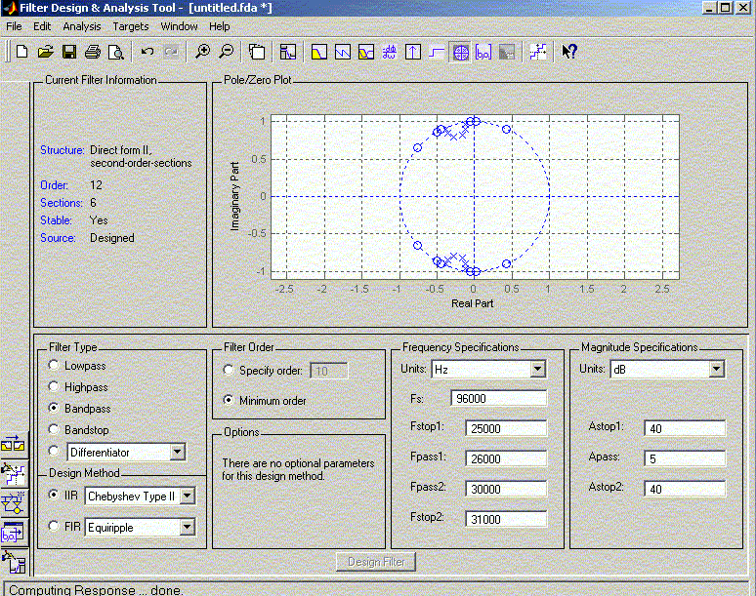
Figure 1 -- ChebychevII Bandpass Filter
Pole-Zero Diagram

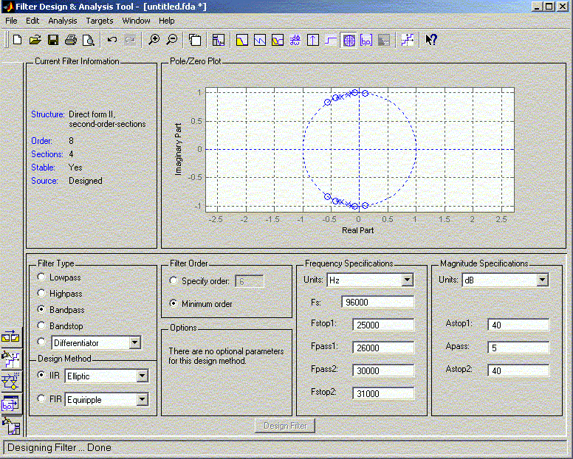
Figure 2 -- Elliptic Bandpass Filter
Pole-Zero Diagram

